Step 1:- Create a normal and a hidden .txt file with some sample text (using echo command)
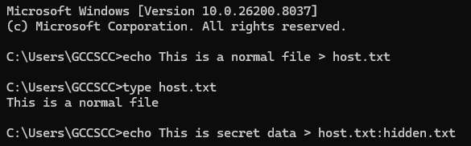
Use suffix :hidden.txt for creating hidden file

Step 2:- View the file in the directory entries using dir for normal file and dir /r for hidden file
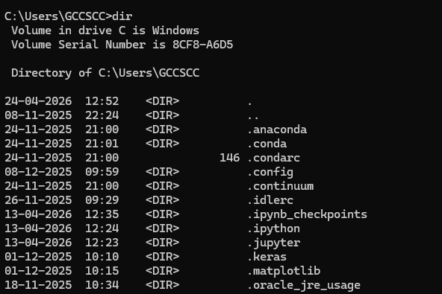
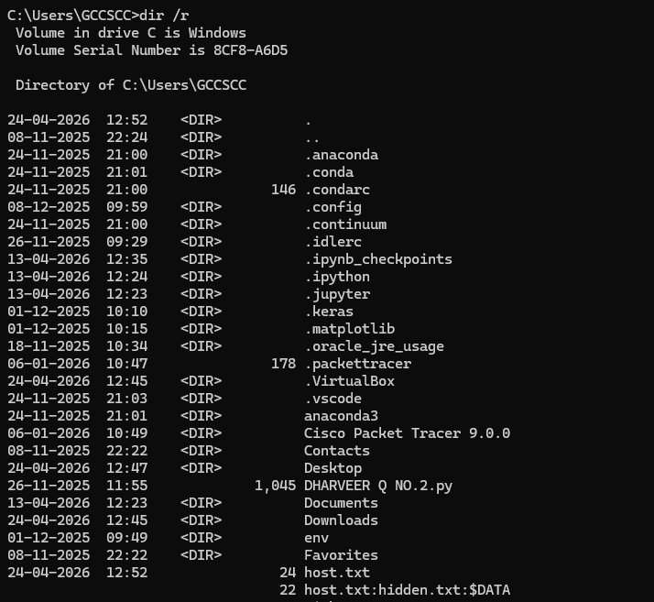

Step 3:- Try the view the contents of the hidden file by opening it in notepad

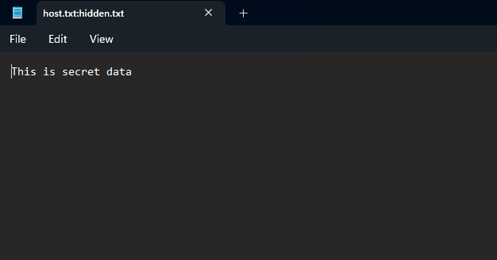
Or by using the more command to view in cmd
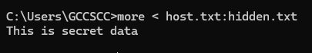

Step 4:- To delete the hidden file delete the parent file host.txt (this deletes both normal and hidden file with name host.txt) and check if it is deleted using dir /r command
